Storyboards, Wireframes, and Prototypes

1) Synopsis: The website is intended for Brooklyn College students to discover or narrow down restaurant options based on some user-defined criteria. These criteria include sorting by pricing, the location’s distance from campus, and food options based on dietary considerations and restrictions. This is an important project as most students are around or on campus during common afternoon hours, and they will likely be interested in food options nearby that match their preferences.

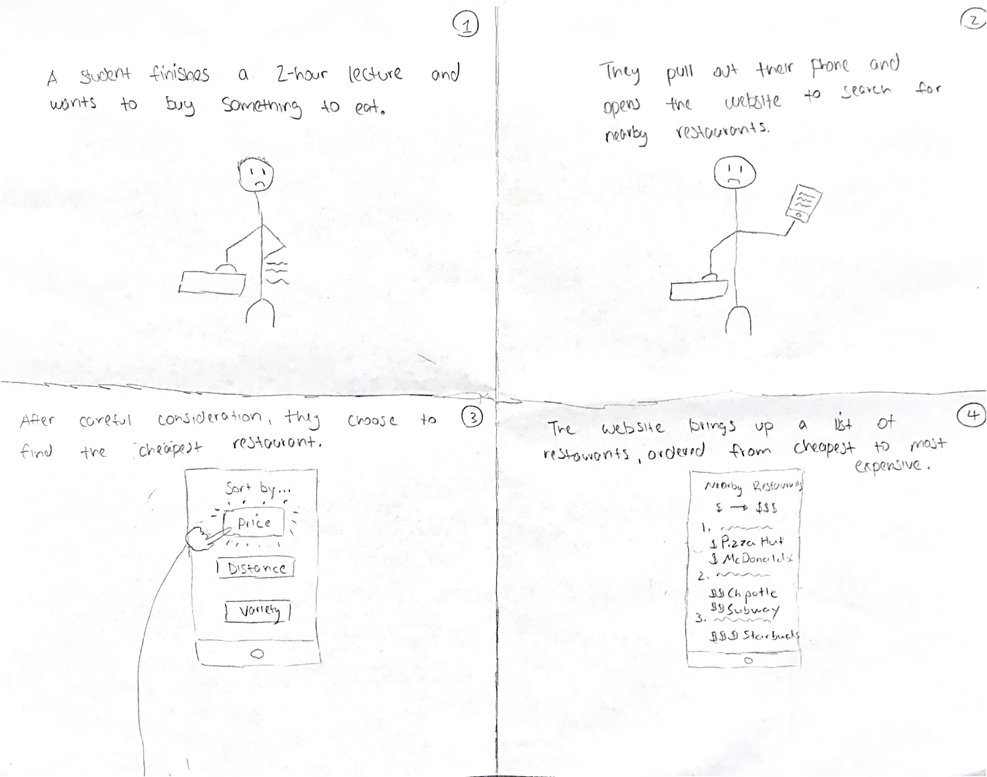

3) We believed that going for a simplistic design to encompass both “tech-newbies” and experienced tech users would be the best course of action and incorporated that idea into our website. Our website has a simple but efficient design that allows the user to accomplish their goal of finding the restaurant that best fits their criteria while also being usable to all.